AU-IQM Hackathon 2022

Team:

Perpetual Motion Squad (PMS)

Devvrat Singh

Dhruvi Patel

Kumail Ghadiali

Karm Rajput

Problem Statement (Beginner Level)

Problem - Bridging the gap between interns and companies.

After thorough analysis and discussions with team, we came to the consensus of choosing the above problem.

Soon after deciding on a problem, we started breaking the problem into smaller chunks.

Later, we distributed each sub-problem to all team members and started working on it.

The sub-problems we all broke it down to were:

* Authentication
* Web-page structuring
* High-level flowchart of website
* Creating webpages with HTML and CSS
* Website design (UX/UI designs)
* The backend Database

The high-level flowchart we created is shown below as an image:

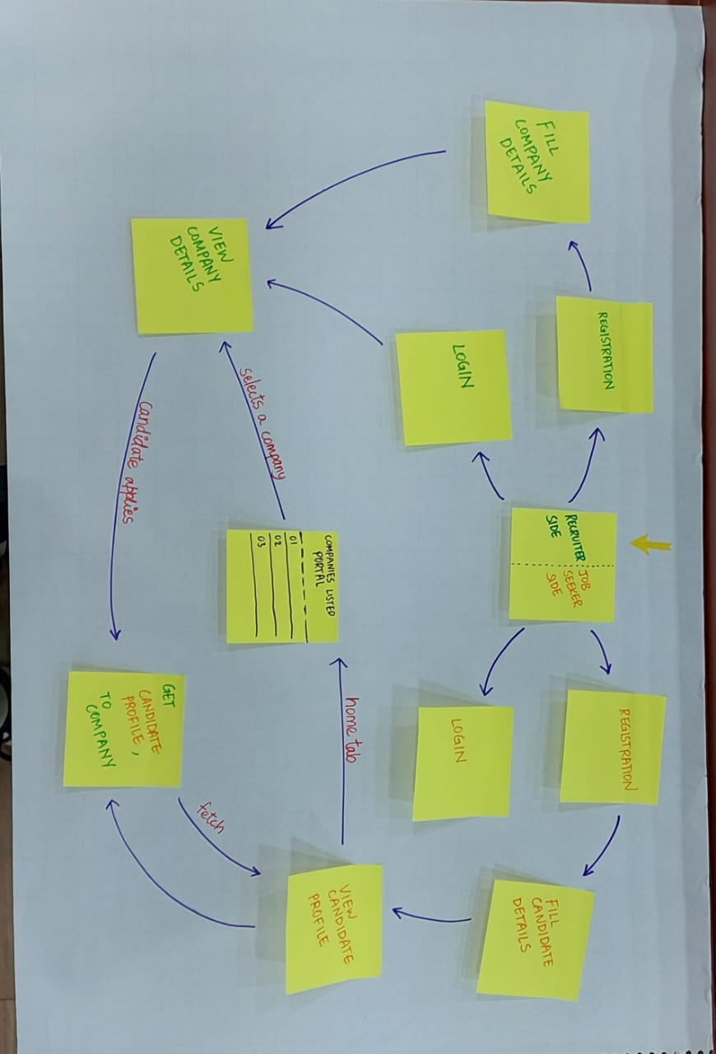

The above flowchart pretty much sums up the entire working of our proposed solution.

We have tried to implement most of the above functionalities into our solution.